**Detector-Specific Quality Assurance Plan**

**For EMCalorimeter Block Production**

**For the sPHENIX Project**

**Physics Department**

**University of Illinois**

**Urbana-Champaign, Illinois**

**Revision 1.0**

**April 6, 2018**

**sPHENIX Project**

DETECTOR-SPECIFIC QUALITY ASSURANCE PLAN

**Approved by:**

_________________________________________ Date

Anne Sickles

sPHENIX L3 Manager for EMCal Block production

University of Illinois Urbana-Champaign

**Accepted by:**

________________________________________ Date

Edward O’Brien

sPHENIX Project Director

Brookhaven National Laboratory

_________________________________________ Date

James Mills

sPHENIX Project Manager - Engineering

Brookhaven National Laboratory

_________________________________________ Date

Glenn Young

sPHENIX Project Manager

Brookhaven National Laboratory

**Detector-Specific Quality Assurance Plan**

**Project Name:** EMCalorimeter Block Production for sPHENIX Project

**Department at BNL:** Physics

**Document Number:** ###

This version of the document may not be the current or approved revision. The current revision is maintained by the Physics Department of the University of Illinois Urbana-Champaign and a copy is kept in the sPHENIX Project’s document management system.

Note: The current approved version is always available in the sPHENIX Project’s document management system. It is also included as part of any subcontact issued by BNL to the University of Illinois Urbana-Champaign for preparing the EMCalorimeter Blocks.

Approvals for this document will be required from:

L3 Manager for EMCal Blocks: Anne Sickles

Quality Assurance Plan Version Control

|  |  |  |  |
| --- | --- | --- | --- |
| Revision | Date | Authors | Change Description |
| 1.0 | 4/4/2018 | Anne Sickles | Initial release |
|  |  |  |  |
|  |  |  |  |
|  |  |  |  |
|  |  |  |  |

LIST OF ACRONYMS AND ABBREVIATIONS

BNL Brookhaven National Laboratory

CD Critical Decision

DOE Department of Energy

DQAP Detector-Specific Quality Assurance Plan

ES&H Environment, Safety and Health

L2 Level 2

L3 Level 3

PHENIX Pioneering High-Energy Nuclear Interacting Experiment

QA Quality Assurance

QAP Quality Assurance Plan

RHIC Relativistic Heavy Ion Collider

SBMS Standards-Based Management System

UIUC University of Illinois Urbana-Champaign

WBS Work Breakdown Structure

**TABLE OF CONTENTS**

LIST OF ACRONYMS AND ABBREVIATIONS 3

1 INTRODUCTION 5

1.1 Purpose 6

1.2 Scope 6

1.3 Approach 6

1.4 Graded Approach 7

1.5 Definitions 7

2 QUALITY ASSURANCE PROGRAM 8

2.1 Responsibility for Managing 8

2.2 Organization and Level of Authority and Interface 8

3 PERSONNEL TRAINING AND QUALIFICATION 9

4 QUALITY IMPROVEMENT 10

5 DOCUMENTS AND RECORDS 10

6 WORK PROCESSES and Procedures 11

7 QA OF KEY PROCURED COMPONENTS 13

7.1 Scintillating Fiber QA 13

7.2 Brass Mesh QA 14

7.3 Tungsten Powder QA 15

7.4 Epoxy QA 16

8 PROCUREMENT 16

9 INSPECTION AND ACCEPTANCE TESTING 17

10 REFERENCES 20

1. INTRODUCTION

The sPHENIX Project is a project to upgrade the Pioneering High-Energy Nuclear Interacting Experiment (PHENIX) detector at the Relativistic Heavy Ion Collider (RHIC) at Brookhaven National Laboratory (BNL). This upgrade brings exciting new capability to the RHIC program by opening new and important channels for experimental investigation and utilizing fully the luminosity of the recently upgraded RHIC facility. It enables a compelling jet physics program that will address fundamental questions about the nature of the strongly coupled quark-gluon plasma discovered experimentally at RHIC to be a perfect fluid. The project is funded by the U.S. Department of Energy (DOE), RIKEN and other organizations.

A key component of sPHENIX is an Electromagnetic Calorimeter, or EMCalorimeter, which is used to detect photons, electrons and positrons and determine their energies and the positions at which they strike the EMCalorimeter. It is positioned inside of and supported from another type of calorimeter, the Inner Hadronic Calorimeter, which serves a similar function for protons, charged pions and heavier ions, and which in turn is supported just inside the superconducting solenoid magnet of the experiment.

The sPHENIX EMCalorimeter consists of 24576 towers covering 2π in azimuthal angle and pseudorapidity η between -1.1 and 1.1, which covers the acceptance of sPHENIX. A tower serves as the basic detection, sensing and readout element of the EMCalorimeter. The basic construction unit of the calorimeter is a *Block* that consists of four readout towers in a 2x2 array. The entire EMCalorimeter is built of 6144 blocks. There are scenarios in which the full scope of the EMCalorimeter is not built. This has no impact on the block QA procedures since the blocks are built individually.

Blocks are built from scintillating fibers arranged in a grid embedded in tungsten powder, which is used as the EMCalorimeter absorber material. The fibers emanate nearly radially from the interaction point at the center of sPHENIX. The powder is held inside the block using epoxy, which infuses the entire block. The fibers are held in place using brass meshes, or screens, (six per block), each of which contains 2668 holes in a hexagonal pattern transverse to the radial direction. The hole spacing between consecutive screens increases going from the front of the block to the back giving approximate projectivity in both pseudorapidity η and azimuthal angle Φ.

The blocks are made in 22 distinct shapes in order to accommodate the increasing

tilt in polar angle needed as they are placed along a cylindrical surface to keep them oriented towards the cylinder's central point, which is the interaction point. Final dimensional controls are achieved by both the precision of the mold used in the filling and gluing step and by post-assembly machining. The specific materials used are discussed in Sections 7 and 8.

The production plan for the EMCalorimeter Blocks includes the plans and procedures described in this document, the Detector-Specific Quality Assurance Plan for the EMCalorimeter Block production.

* 1. Purpose

The purpose of this Detector-Specific Quality Assurance Plan (DQAP) is to establish the Quality Assurance (QA) requirements for EMCalorimeter Block production for sPHENIX and describe how the requirements will be met, using a graded approach. This plan describes the EMCalorimeter Block production project’s QA activities, which are conducted largely at the Physics Department of the University of Illinois Urbana-Champaign (UIUC) and culminate in reception testing at BNL after shipping from UIUC, and is implemented via processes described herein that address specific quality requirements.

* 1. Scope

This DQAP provides requirements applicable to EMCalorimeter Block production for sPHENIX, encompassing all activities, including but not limited to fabrication and testing at UIUC, and shipping to BNL. Specific QA procedures are described in the following for raw materials and component testing, EMCalorimeter block manufacturing, and testing prior to shipment to BNL. The production work to be done will be described in a Statement of Work (SOW) issued by BNL/sPHENIX and incorporated into a subcontract between BNL and UIUC.

* 1. Approach

UIUC Physics will be the responsible organization for implementing the QA requirements for all EMCalorimeter Block production activities through completion of block fabrication, testing and subsequent shipment to BNL.

Additional EMCalorimeter Block production QA procedures will be developed, as necessary, if early production experience indicates they are warranted. Similarly, the QA procedures listed herein may be modified or improved, as experience dictates. All such additions and modifications will be captured in a formal revision to this DQAP.

* 1. Graded Approach

This DQAP embodies the concept of graded approach; that is, selecting and applying an appropriate level of analysis and controls to work activities, equipment, and items commensurate with the potential for environmental, safety, health, radiological, or programmatic impact.

* 1. Definitions

The following is a list of definitions for terminology used in this plan:

**Electromagnetic Calorimeter (EMCalorimeter)**– Device for measuring the energy and position of photons, electrons and positrons striking it.

**Electromagnetic Calorimeter Block (EMCalorimeter Block) –** A basic construction unit of an EMCalorimeter, consisting of absorber material and active sensing material, and including coupling to a sensing device, e.g. an optical sensor, that can convert the basic signals generated into electrical impulses that can be recorded and archived.

**Scintillating Fiber –** An active sensing material used in an EMCalorimeter Block and which consists of a thin 1-2 mm diameter extruded plastic filament which is doped with typically 1% of organic dye. Charged particles traversing the scintillating fiber lose energy which appears as optical light and is conducted to an end of the fiber, which in turn couples to an optical sensing device.

**Brass Screen –** A thin perforated sheet of brass which is used to position the scintillating fibers into a regular hexagonal array.

**Tungsten Powder –** Finely ground tungsten metal, which serves as the absorber material for the EMCalorimeter and causes incident photons, electrons and positrons to interact, creating secondary particles which in turn are then sensed by the scintillating fibers.

**Measuring and Test Equipment (M&TE)** - Devices or systems used to calibrate, measure, gauge, test, inspect, or control to acquire research and development, test, or operational data to determine compliance with design, specifications, or other technical requirements

**Quality** **(Q)** - The condition achieved when an item, service, or process meets or exceeds the user’s requirements and expectations.

**Quality Assurance (QA)** -All actions and controls necessary to provide confidence that quality is achieved.

**QA Plan (QAP)** -The document describing the QA program requirements that the project will implement.

**QA Program** - The overall program or management system established to assign responsibilities and authorities, define policies and requirements, and provide for the performance and assessment of work.

1. QUALITY ASSURANCE PROGRAM

The EMCalorimeter Block production is included in the sPHENIX project’s Work Breakdown Structure (WBS) under section WBS 1.03.01 and includes therein all preproduction and production steps together with an enumeration of the delivered objects, the EMCalorimeter Blocks.

* 1. Responsibility for Managing

The sPHENIX L3 Managers are responsible for constructing specific items of apparatus, such as the EMCalorimeter Blocks, following a DQAP developed for the specific item, and reporting their QA issues to their respective L2 manager and as needed to the sPHENIX Project Director.

The block production is the responsibility of the University of Illinois sPHENIX group. The block production will be carried out at the UIUC Nuclear Physics lab under the supervision of the technical staff there. Any quality problems identified will be resolved by consulting with sPHENIX project management at BNL.

* 1. Organization and Level of Authority and Interface

This DQAP for EMCal Block Productiondefines the responsibility, authority, organization and interrelation of personnel who manage, perform, and verify work that affects EMCalorimeter Block quality.

All employees of UIUC are responsible for the quality of the work that they perform and/or supervise for EMCalorimeter Block production. Each has the authority to stop work and report adverse conditions that affect the quality of the project deliverables to their respective managers. The L3 Manager for the EMCal Block production is responsible for the EMCalorimeter Block components and determines and documents their acceptance criteria. Management at each level is responsible for evaluation of quality through management assessments; however, independent assessments may be requested by sPHENIX management.

1. PERSONNEL TRAINING AND QUALIFICATION

The L3 Manager for EMCalorimeter Block production is responsible for ensuring that all UIUC staff members are trained and qualified to perform their assigned work effectively and safely.

Before personnel are allowed to work independently, the L3 Manager for EMCalorimeter Block production is responsible for ensuring personnel have the necessary experience, knowledge, skills, and abilities. Personnel qualifications are based on factors such as:

* Previous experience, education, and training
* Performance demonstrations or tests to verify previously acquired skills
* Completion of training or qualification programs
* On-the-job training.

All project participants are responsible for ensuring that their training and qualification requirements are fulfilled.

The Illinois Nuclear Physics Lab (NPL) at UIUC has extensive experience building detectors for nuclear physics experiments including calorimetry.

The group led by Assistant Professor Anne Sickles, the L3 Manager for EMCalorimeter Block production, has been leading the tungsten powder-scintillating fiber EMCalorimeter development for sPHENIX for three years and has successfully built blocks for three prototype calorimeters (Ref.1).

Research Assistant Professor Caroline Riedl will oversee the factory starting in the summer of 2018. She has extensive experience overseeing physics detector construction including management of the COMPASS DC5 construction and a term as Technical Coordinator of COMPASS.

The UIUC NPL technical staff is led by Eric Thorsland who has many years of experience working on a wide variety of nuclear physics detectors including the BNL g-2 calorimeters and prototype for the Fermilab g-2 calorimeters (Ref.3).

Sickles, Riedl and Thorsland will train and supervise the student workers. They will ensure that all safety requirements are met and that the training records kept are accurate and up to date. The students will be involved in the fiber filling and post-machining inspection. Initially, UIUC NPL staff will regard the student as qualified after ten blocks and this will be revisited after the construction of the preproduction prototype blocks.

1. QUALITY IMPROVEMENT

Processes to detect and prevent quality problems will be established and implemented, including:

* Inspection and testing
* Work planning
* Assessments

Item characteristics, process implementation, and other quality-related information will be reviewed, and the data analyzed to identify items and processes needing improvement.

Problems identified by assessment, test, inspection, and other means will be controlled and corrected using the graded approach described in this plan. Where appropriate, the cause(s) of the problem will be identified and corrected to prevent recurrence.

To promote continual improvement, suggestions for process improvement will be gathered throughout the duration of the EMCalorimeter Block production. These will be communicated to sPHENIX project management.

Project participants are encouraged to identify problems or potential quality improvements.

1. DOCUMENTS AND RECORDS

Documents will be prepared, reviewed, approved, issued, used, and revised to prescribe processes and specify requirements, and to fabricate, review, and repair if necessary, the EMCalorimeter Blocks.

Project management and the L3 Manager for EMCalorimeter Block production are responsible for identifying the records to be preserved. Records that show evidence or proof that a decision was made, or an action taken, will be part of the records submitted. Records for the EMCalorimeter Block production project will be kept in a database for the project located in https://docs.google.com and keyed specifically to this project. This guarantees regular archiving (backups) of the data are made and also enables remote access under permission control.

The L3 Manager for EMCalorimeter Block production is responsible for bringing to the attention of project management any deficiencies in documentation that compromise the performance and reliability goals for the EMCalorimeter Blocks.

Block identification and key manufacturing parameters to be recorded are noted here.

Each EMCalorimeter Block will receive a database number DBN. The DBN will be issued when the fiber filling of the meshes starts and will persist through the block placement in sPHENIX. The DBN will be associated with both the block characteristics (type of block, physical measurements, etc.), but also with the names of technicians and students who worked on the block and the batches of raw materials which were used to fabricate the block. This information will be tracked in a computer-based Traveler as the block is produced. An index of all Travelers will be kept in a summary Spreadsheet. The Travelers and summary Spreadsheet with be archived on a regular basis. The Spreadsheet provides a compact way of keeping track of the over 6000 Travelers for individual Blocks.

The fields in the Traveler will be: block type, fiber filler (name of person), fiber filling check (name of person), fiber filling date, mold number, mass of tungsten powder, vibration time, epoxy preparer, epoxy filling time, powder batch, fiber batch, epoxy batch dimensions after machining, fiber count, machined block mass, machined block density.

The block itself will have the DBN written on the side of the block using a black permanent marker.

The final designs of the EMCalorimeter Blocks were prepared by BNL, and the final drawings of all block types to be manufactured, as agreed upon by UIUC with BNL, are archived at BNL. Any modifications need to be agreed on by BNL and UIUC sPHENIX group.

Access to the block Travelers and Spreadsheet noted above will be provided to BNL and a final copy will be provided to BNL upon completion of the work. A paper copy of the corresponding records will be shipped along with the blocks.

The digital height meters that will be used to check and record dimensions, will be checked at set intervals. They will be calibrated against standard gauges. The scale used for the epoxy weighing is calibrated using standard weights. The results of these checks will be recorded.

1. WORK PROCESSES AND PROCEDURES

The L3 Manager for EMCalorimeter Block production is required to identify the resources and support systems to enable staff to do their work.

The work procedures for the EMCalorimeter Block production QA steps are listed in the following sections below.

The QA methods and procedures for the sPHENIX EMCalorimeter Blocks have been established over the R&D phase from 2015 to 2018. Three prototype calorimeters have been constructed:

* 1D projective calorimeter where each block was two towers. This calorimeter was tested in beam at Fermilab and the energy resolution is documented in Ref.1.
* 2D projective calorimeter testing the high η region (i.e. more forward angles) of sPHENIX, the v2.1. Each block consists of four towers. The resolution for this calorimeter is documented in Ref.2.
* 2D projective calorimeter testing the high η region of sPHENIX, the v2.1. This calorimeter has a very similar geometry to the v2 prototype but improvements in the QA procedures and overall block quality. This calorimeter was being tested in beam during February 2018 at Fermilab.

**Methodology of meeting specifications during block fabrication**

There are three objectives that need to be met during block fabrication to ensure the

blocks meet the physics requirements:

* *Fiber filling:*
* The blocks have to have the correct number of fibers filled through the meshes to ensure uniform light transmission
* Each fiber assembly (all block shapes) which contains 2668 fibers, is filled by one student. Another person (student or technician) checks the fiber assembly by looking for missing fibers. The students have clean hands to fill the fibers but do not wear gloves because the fibers are easier to manipulate without them. The area is kept away from the tungsten fiber filling area of the lab.
* *Tungsten filling:*
* The blocks need to be filled with the correct amount of tungsten powder to ensure the blocks have the required density

There is a minimum powder amount for each block shape that is kept in a spreadsheet linked to the University of Illinois internal lab website. This minimum powder amount is based on our experience making the V2.1 blocks for block shapes 19-22 and will be revised based on the Sector 0 block production for the other block shapes.

* The epoxy needs to be filling the entire block uniformly

The epoxy is added to the open top mold from the top. To ensure that the epoxy reaches the bottom of the mold a vacuum pump is connected to the ports at the bottom of the mold.

The epoxy must appear at the bottom ports for us to know that the block has been fully infused with epoxy. The time until the epoxy appears, and the amount of epoxy used are noted in the block spreadsheet.

* *Machining & Finishing*
* After the epoxy is dry the blocks are removed from the mold. The block needs to be machined on three surfaces:
* The top of the block needs to be machined due to the excess powder and epoxy from the filling of the fiber assembly in the previous steps.
* The ends of the block need to be machined to expose the fiber ends and have a smooth surface for the reflector (back of block) and light guides (front of block) to be epoxied to.
* After machining the block dimensions are measured using a surface table and a digital height meter (Mitutoyo 570-312, precision ±0.0015 in). The blocks will be measured at the ends and the heights will also be recorded at the screen positions along the block side. The acceptable tolerances will be established after the building of a full sector prototype and used to control acceptance of the production blocks.

1. QA OF KEY PROCURED COMPONENTS

The design of the sPHENIX EMCalorimeter Blocks is complete and has been verified by construction of several dozen prototype EMCalorimeter Blocks and operation of these prototype blocks in a test beam of identified particles at the Fermi National Accelerator Laboratory. The prototype EMCalorimeter Blocks did meet the performance specifications for the sPHENIX EMCalorimeter. The prototype EMCalorimeter Blocks used the final materials and forms of all manufactured parts and were assembled using the expected final procedures. The essential components for EMCalorimeter Block production which must be procured from vendors are identified from this effort. They will be subjected to the following QA requirements as noted below as part of their procurement.

* 1. Scintillating Fiber QA

Scintillating Fiber attenuation length will be specified in the procurement design specifications for the fiber procurement and will be provided to the manufacturer. The manufacturer will sample test fiber batches at a rate of ≤0.02% as part of their manufacturing quality assurance. Documentation of the manufacturer's tests will be supplied along with the fibers.

* Fibers from each batch will be checked for light output relative to reference fibers which we have found previously to produce acceptable quality blocks.
* Fibers that do not meet the dimensional tolerances specified would be rejected at the screen-filling step, as they will not fit into the screens.
* Each box of fibers will be inspected upon receipt. If any significant marks or breaks are noted, photographs are taken. They crate is opened and the interior is inspected. Photographs are taken if anything appears out of the ordinary. It is recorded in the database.
* Fibers will be stored in a dark, temperature-controlled environment.
  1. Brass Mesh QA

The Brass Meshes are made by Tech-Etch. An example Mesh, or screen, drawing is shown in Figure 1.

UIUC had no instances of brass meshes that did not meet specifications during prototype EMCalorimeter Block production. The brass meshes will be ordered as a single order and so there will be a single batch of each mesh type. The mesh batch will not be recorded because all the brass meshes will be ordered at once so there will only be one batch. The presence of all holes will be verified by stacking meshes and inspecting them under illumination. Hole diameter is checked by insertion of a standard fiber as a go/no-go check.

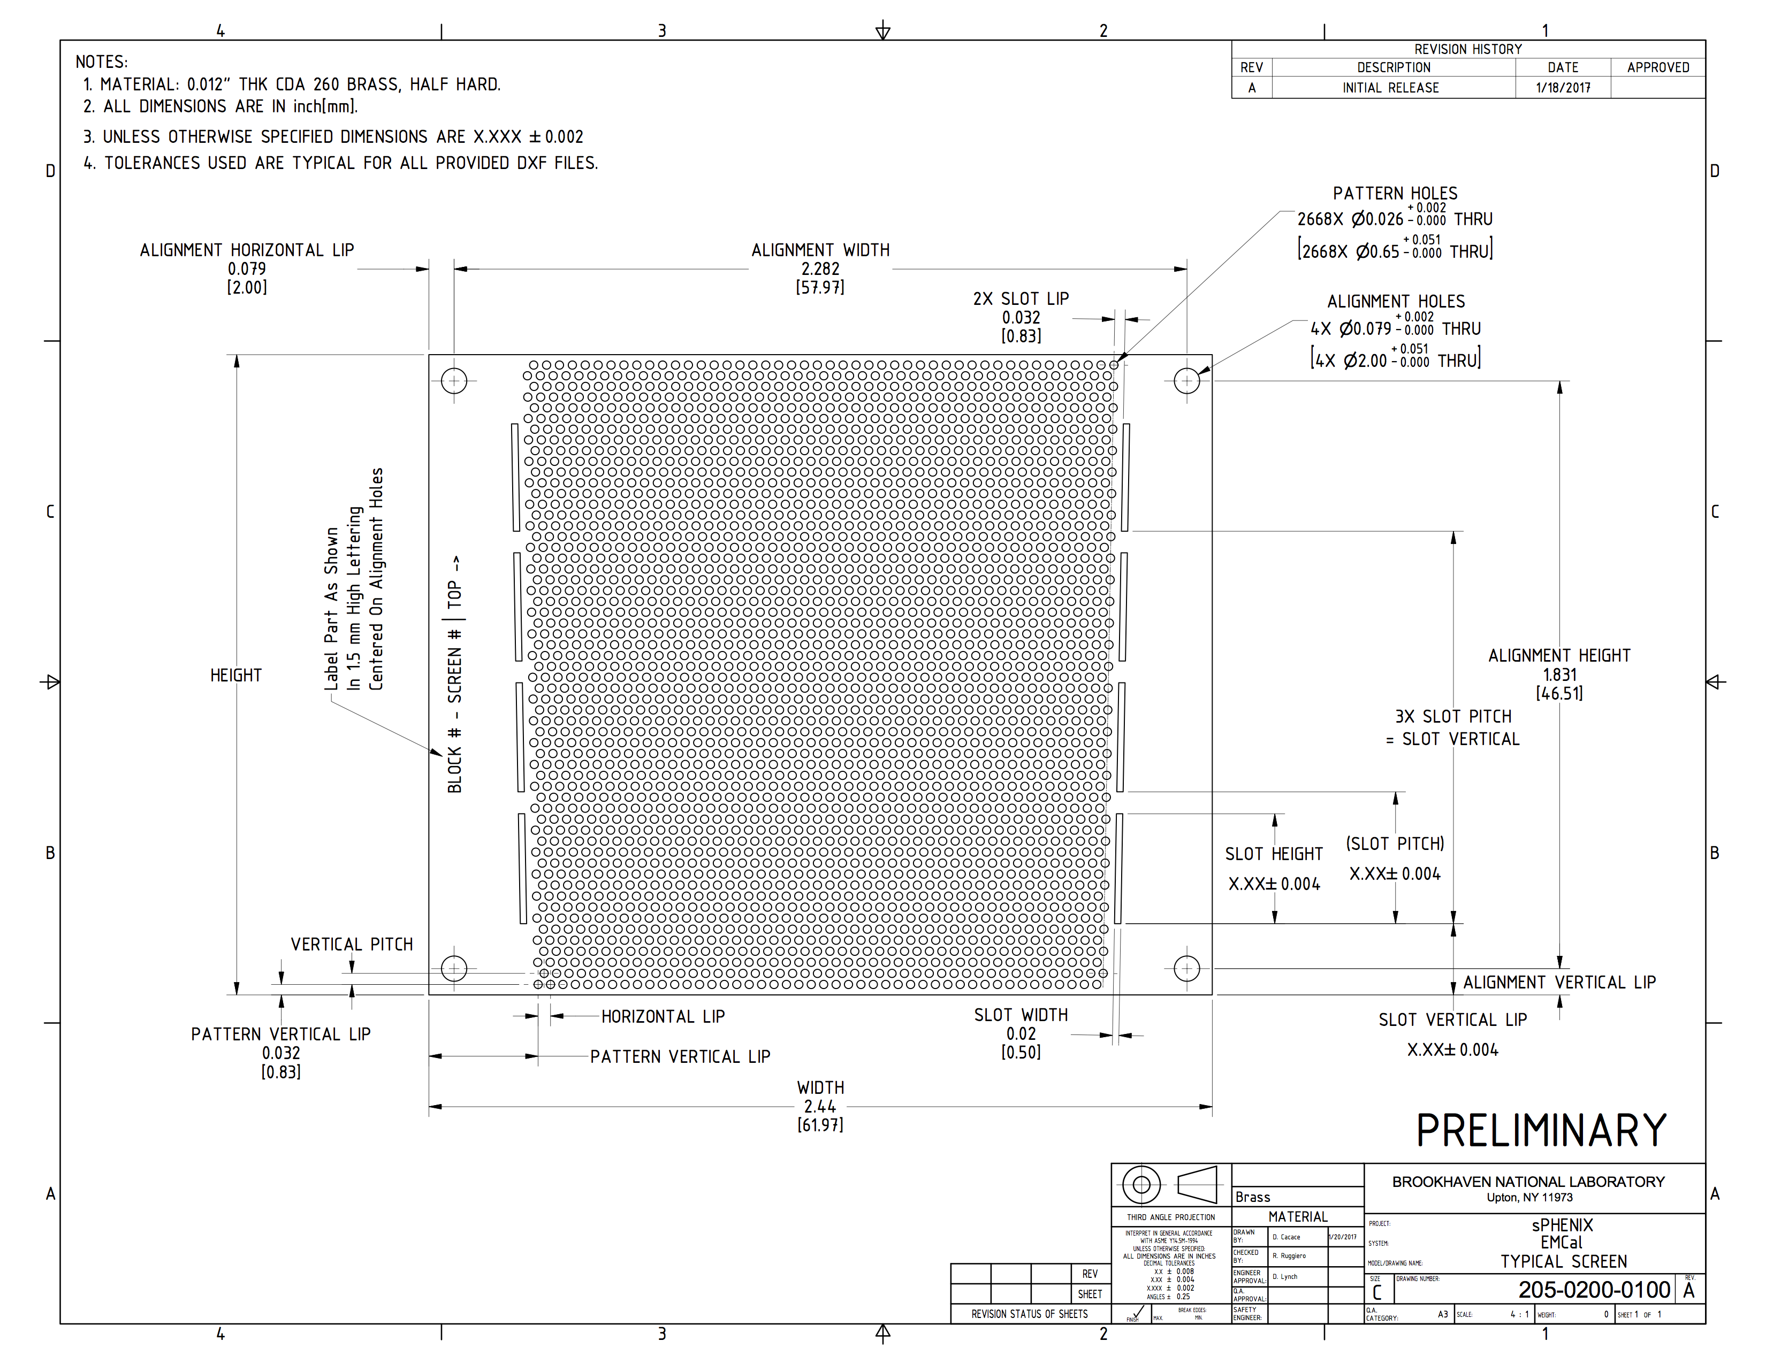

Figure 1: An example brass mesh (screen) drawing.

* 1. Tungsten Powder QA

Tungsten powder can vary significantly depending on the purity of the powder and the particle size distribution. The tungsten has typically been shipped in 50-100lb buckets. UIUC will establish baseline density and purity measurements in the preproduction EMCalorimeter Blocks and then will perform basic tests on each bucket and more detailed tests on a random selection of buckets and any bucket that is flagged by the random tests. For each bucket UIUC will:

* Visually inspect the powder
* Measure and record the tap density. For those buckets which are to receive the secondary screening UIUC will:
* Test the chemical composition of the powder using an inductively-coupled plasma atomic emission spectroscopy (ICP) and compare to a reference composition
* Take scanning electron microscope (SEM) images of the powder and compare to a reference

Both the ICP and SEM are resources available at the University of Illinois.

If the density is below the required minimum density or the particle size distribution deviates significantly from the average, UIUC will reject the bucket. These requirements and a range of acceptable values will be finalized during the construction of the preproduction prototype. The results of all tests and shipment details will be recorded in the database by the bucket ID number.

UIUC will note in the database entry for each block an ID number for the powder bucket.

* 1. **Epoxy QA**

Each epoxy shipment is inspected for the condition of the resin and hardener containers. The expiration date is checked and recorded along with the lot number.

The epoxy will be stored in a temperature-controlled area. It is never stored below 17o C. If the temperature of the epoxy storage area goes below 17o C the epoxy is heated to and tested to ensure that crystallization does not occur.

The epoxy will be mixed at the proper ratio using the digital scale near the fume hood where the epoxy is used. The epoxy mixing occurs in plastic drinking cups and is mixed in batches of 100 gm using 8 gm of resin and 20 gm of activator. The quantities will be measured using a scale with a precision of 0.1 g; this has been found to be sufficient for mixing this epoxy in UIUC experience. The epoxy will be heated on a warming plate to 35-37o C to reduce its viscosity to allow it to flow better through the mold. The temperature of the room is important to ensure that the epoxy flows well. The room is at 21o C with ≤50% humidity. Each block uses approximately 185 gm of epoxy (some variation exists due the different sizes of the blocks).

1. PROCUREMENT

Procurement controls will be implemented to ensure that purchased items and services meet project needs and comply with applicable quality requirements.

The main procurements are:

* Tungsten powder (100 mesh), THP technon 100 or similar.
* Scintillating Fibers are 0.47~mm clear scintillating fibers in 1.2~m canes from St Gobain or Kuraray. The scintillating fibers will be ordered from BNL and the specifications on that procurement are detailed in a separate document.
* Epoxy is specified to be model Epo-tek 301
* Meshes are brass meshes manufactured by Tech-Etch, using the drawing noted in Section 7
* The UIUC NPL will acquire consumables as needed.

Specifications that adequately describe the items being procured, so that the suppliers understand what is desired and what will be accepted, have been developed. Prototype quantities have been acquired to check technical performance requirements are met and that acceptance criteria can be met.

The L3 Manager for EMCalorimeter Block production will use established QA processes as noted above in Section 7 to ensure that procured items and services meet the established requirements and perform as specified. The requirements for inspection and acceptance testing have been determined and noted under the QA steps for procured items as discussed in Section 7.

Unacceptable items or services are documented. Records of supplier performance (e.g., inspection and test records and contract-required submittals) will be maintained.

Counterfeit and/or suspect parts are prohibited. Inspections will be used to detect violations.

1. INSPECTION AND ACCEPTANCE TESTING

Inspection and testing of EMCalorimeter Block materials and final blocks will be conducted using established acceptance and performance criteria, and equipment used for inspection and tests will be calibrated and maintained.

The finished EMCalorimeter Blocks are judged and accepted based on three criteria:

* dimensional compliance
* light transmission yield and uniformity
* density

The final decision on the blocks is based on meeting the dimensional requirements, having good light transmission, and block density within the acceptable range.

* Following the block fabrication and machining the number of light transmitting fibers will be counted using a software program taking as input an image of the illuminated block end. With the fiber counting program we expect to count over 2650 fibers (over 99.5% of the total expected fibers).
* The loss measured by this program includes both losses from fibers actually missing from the fiber assembly and artifacts in the software program which lead to pairs of fibers being merged in some cases when they are pushed close together on the read out end of the block. If the fiber counting program returns less than 2650 fibers the block will be examined to determine if the low fiber count results from fiber merging or excessive missing fibers. If it is missing fibers the block will be rejected.

The measurement dimensions for the blocks are shown in Figure 3

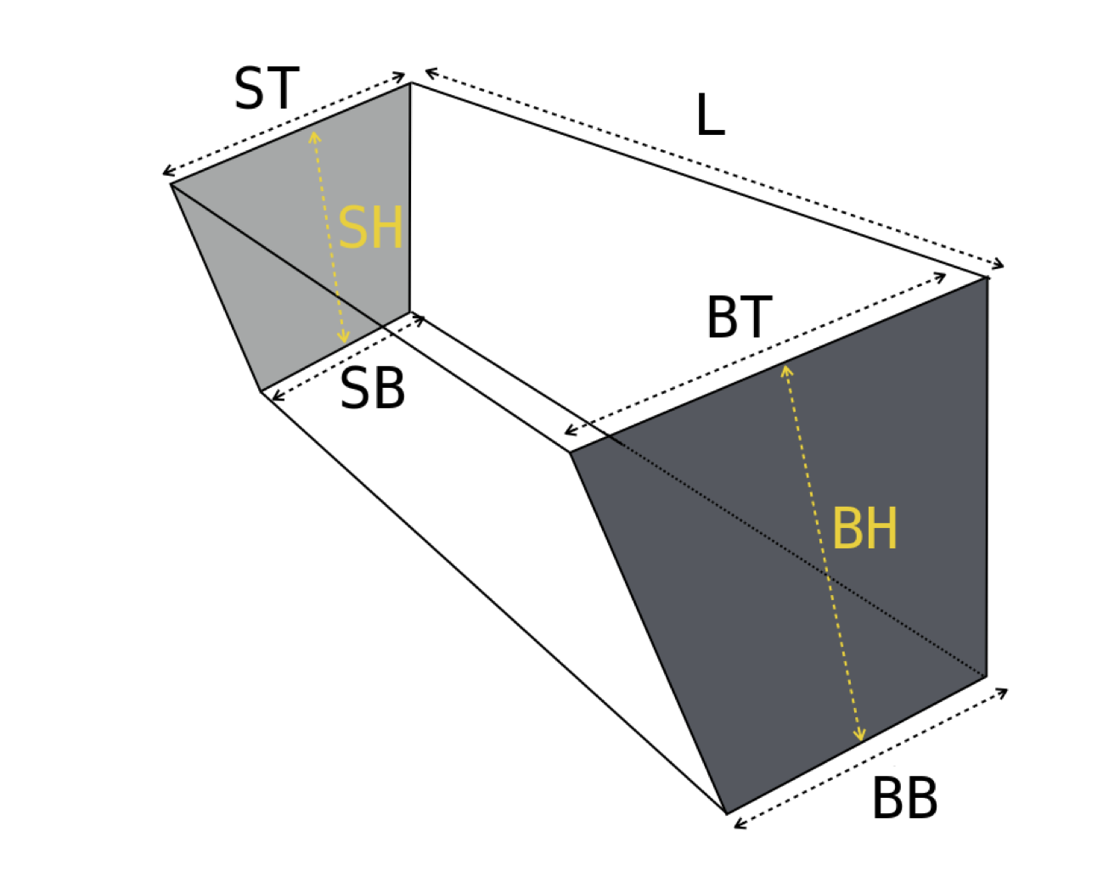

* The tolerance on each dimension is $+$0.010~in. If a block dimension is out of tolerance, the block will be re-machined if possible to meet the specifications.
* The molds will be reused many times. We will keep track of which mold was used to make each block so that a mold which produces out-of-tolerance blocks will be discarded or reworked.

BNL will supply the UIUC Nuclear Physics Lab with a mechanical support structure for the blocks identical to the ones that the sectors will be epoxied to. NPL staff will order the blocks for a full sector on the support structure in a way that minimizes the gaps between blocks. The ordering of the blocks for each sector will be sent to BNL along with the blocks.

* Blocks with a density below 9.0~g/cm3 or which have evidence of non-uniform powder and epoxy distribution will be rejected.

Blocks, which pass the QA requirements, will be shipped to BNL where they will be assembled into sectors. The blocks will be individually wrapped and shipped in appropriate containers to BNL using standard shipping services.

The shipping fixtures have not yet been designed but NPL staff is considering reusable crates that will be shipped back to UIUC empty from BNL. For prototype blocks NPL staff have used bubble wrap and foam padding inside the buckets that the tungsten powder arrives in. For production blocks NPL staff will revisit this.

**Non-conforming items**

Individual blocks that do not meet the fiber number, density or light transmission criteria will be rejected. Blocks which are out of dimensional tolerances will be re-machined if possible to bring them into tolerance. The final mechanical check of the blocks will be the assembly in the sector mock up at UIUC NPL. At that point the ordering of specific blocks into a sector will be fixed for all blocks in that sector.

A tally of non-conforming blocks and the non-conforming specifications will be kept and reviewed periodically by BNL.

The L3 Manager for EMCalorimeter Block production is the responsible person to determine whether a given Block is accepted or rejected and will communicate these decisions to the sPHENIX project management.

Designated inspection/tests will be performed using equipment that is calibrated and maintained. The calibration status will be readily discernible and associated calibration procedures, documentation, and records shall be prepared and maintained. Calibrated equipment will be properly protected, handled, and maintained to preclude damage that could invalidate its accuracy. Measuring and test equipment (MT&E) that is found out of calibration will be identified and its impact evaluated.

All inspection and acceptance testing results will be maintained as project records.

1. REFERENCES
2. C. Aidala et al., Design and Beam Test Results for the sPHENIX Electromagnetic and Hadronic Calorimeter Prototypes. Submitted to: *IEEE Trans. Nucl. Sci.,* 2017. arXiv:1704.01461.1
3. sPHENIX Collaboration. URL: <https://indico.bnl.gov/conferenceDisplay.py?confID=3854>
4. R. McNabb, J. Blackburn, J. D. Crnkovic, D. W. Hertzog, B. Kiburg, J. Kunkle, E. Thorsland, D. M. Webber and K. R. Lynch. A Tungsten/Scintillating Fiber Electromagnetic Calorimeter Prototype for a High-Rate Muon g-2 Experiment. *Nucl. Instrum. Meth.*, **A602**:396-402, 2009. arXiv:0910.0818, doi:10.1016/j.nima.2009.01.007.